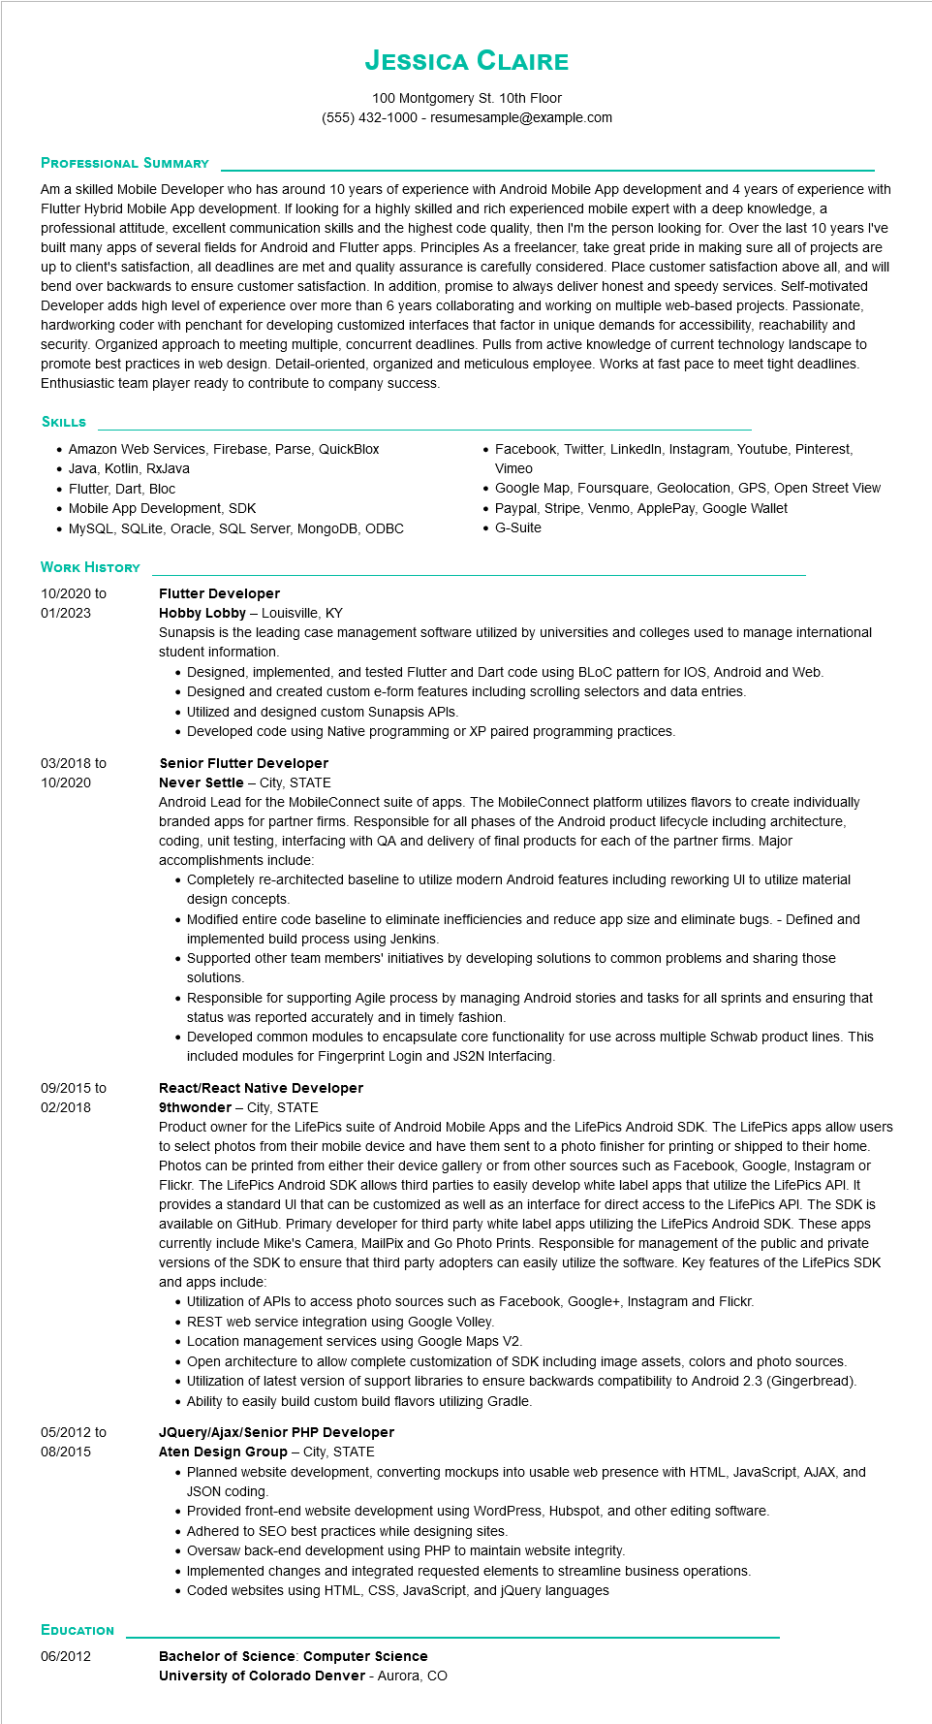
JESSICA CLAIRE
100 Montgomery St. 10th Floor (555) 432-1000 - resumesample@example.com
PROFESSIONAL SUMMARY
Am a skilled Mobile Developer who has around 10 years of experience with Android Mobile App development and 4 years of experience with Flutter Hybrid Mobile App development. If looking for a highly skilled and rich experienced mobile expert with a deep knowledge, a professional attitude, excellent communication skills and the highest code quality, then I'm the person looking for. Over the last 10 years I've built many apps of several fields for Android and Flutter apps. Principles As a freelancer, take great pride in making sure all of projects are up to client's satisfaction, all deadlines are met and quality assurance is carefully considered. Place customer satisfaction above all, and will bend over backwards to ensure customer satisfaction. In addition, promise to always deliver honest and speedy services. Self-motivated Developer adds high level of experience over more than 6 years collaborating and working on multiple web-based projects. Passionate, hardworking coder with penchant for developing customized interfaces that factor in unique demands for accessibility, reachability and security. Organized approach to meeting multiple, concurrent deadlines. Pulls from active knowledge of current technology landscape to promote best practices in web design. Detail-oriented, organized and meticulous employee. Works at fast pace to meet tight deadlines. Enthusiastic team player ready to contribute to company success.
SKILLS
• Amazon Web Services, Firebase, Parse, QuickBlox
• Java, Kotlin, RxJava
• Flutter, Dart, Bloc
• Mobile App Development, SDK
• MySQL, SQLite, Oracle, SQL Server, MongoDB, ODBC
WORK HISTORY
• Facebook, Twitter, LinkedIn, Instagram, Youtube, Pinterest, Vimeo
• Google Map, Foursquare, Geolocation, GPS, Open Street View
• Paypal, Stripe, Venmo, ApplePay, Google Wallet G-Suite
10/2020 to 01/2023
Flutter Developer
Hobby Lobby - Louisville, KY
Sunapsis is the leading case management software utilized by universities and colleges used to manage international student information.
• Designed, implemented, and tested Flutter and Dart code using BLOC pattern for IOS, Android and Web.
• Designed and created custom e-form features including scrolling selectors and data entries.
• Utilized and designed custom Sunapsis APIs.
• Developed code using Native programming or XP paired programming practices.
03/2018 to 10/2020
Senior Flutter Developer
09/2015 to
02/2018
05/2012 to 08/2015
Never Settle - City, STATE
Android Lead for the MobileConnect suite of apps. The MobileConnect platform utilizes flavors to create individually branded apps for partner firms. Responsible for all phases of the Android product lifecycle including architecture, coding, unit testing, interfacing with QA and delivery of final products for each of the partner firms. Major accomplishments include:
• Completely re-architected baseline to utilize modern Android features including reworking UI to utilize material design concepts.
• Modified entire code baseline to eliminate inefficiencies and reduce app size and eliminate bugs. - Defined and implemented build process using Jenkins.
• Supported other team members' initiatives by developing solutions to common problems and sharing those solutions.
• Responsible for supporting Agile process by managing Android stories and tasks for all sprints and ensuring that status was reported accurately and in timely fashion.
• Developed common modules to encapsulate core functionality for use across multiple Schwab product lines. This included modules for Fingerprint Login and JS2N Interfacing.
React/React Native Developer
9thwonder - City, STATE
Product owner for the LifePics suite of Android Mobile Apps and the LifePics Android SDK. The LifePics apps allow users to select photos from their mobile device and have them sent to a photo finisher for printing or shipped to their home. Photos can be printed from either their device gallery or from other sources such as Facebook, Google, Instagram or Flickr. The LifePics Android SDK allows third parties to easily develop white label apps that utilize the LifePics API. It provides a standard UI that can be customized as well as an interface for direct access to the LifePics API. The SDK is available on GitHub. Primary developer for third party white label apps utilizing the LifePics Android SDK. These apps currently include Mike's Camera, MailPix and Go Photo Prints. Responsible for management of the public and private versions of the SDK to ensure that third party adopters can easily utilize the software. Key features of the LifePics SDK and apps include:
• Utilization of APIs to access photo sources such as Facebook, Google+, Instagram and Flickr.
• REST web service integration using Google Volley.
• Location management services using Google Maps V2.
Open architecture to allow complete customization of SDK including image assets, colors and photo sources.
• Utilization of latest version of support libraries to ensure backwards compatibility to Android 2.3 (Gingerbread). • Ability to easily build custom build flavors utilizing Gradle.
JQuery/Ajax/Senior PHP Developer
Aten Design Group City, STATE
• Planned website development, converting mockups into usable web presence with HTML, JavaScript, AJAX, and JSON coding.
• Provided front-end website development using WordPress, Hubspot, and other editing software.
• Adhered to SEO best practices while designing sites.
• Oversaw back-end development using PHP to maintain website integrity.
Implemented changes and integrated requested elements to streamline business operations.
• Coded websites using HTML, CSS, JavaScript, and jQuery languages
EDUCATION 06/2012
Bachelor of Science: Computer Science
University of Colorado Denver - Aurora, CO

